- Go to Cougarweb | 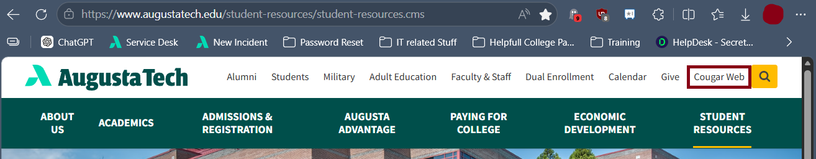
- Enter your Augusta Tech email (i.e – jdoe1@smartweb.augustatech.edu) and click the next button. Enter your password on the next screen, then click the Verify button. | 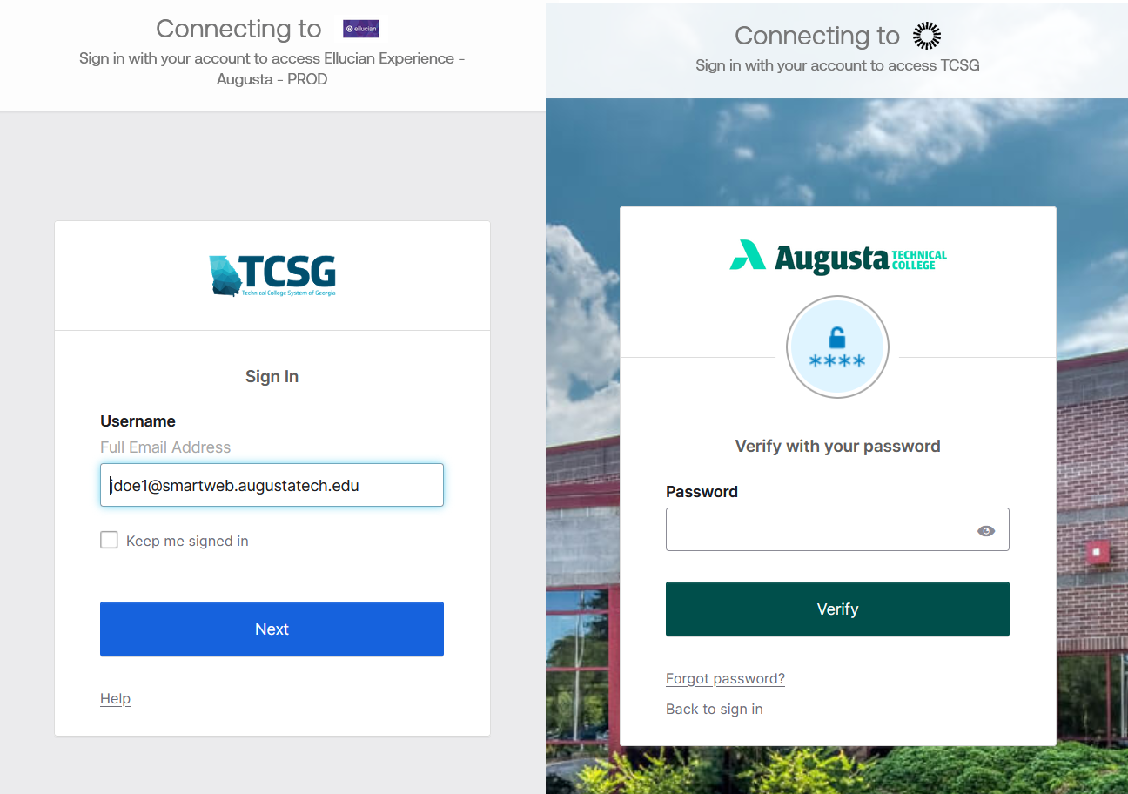
- If this is your First Time signing in, you may be asked to change your password, then you will set up your security questions  - Click set up  - Then you can Choose a security question or create your own.  If you already set this up skip to step 4  Note: Please write these down or make them something you will remember!  This will be used to verify you if you try to reset your password. | 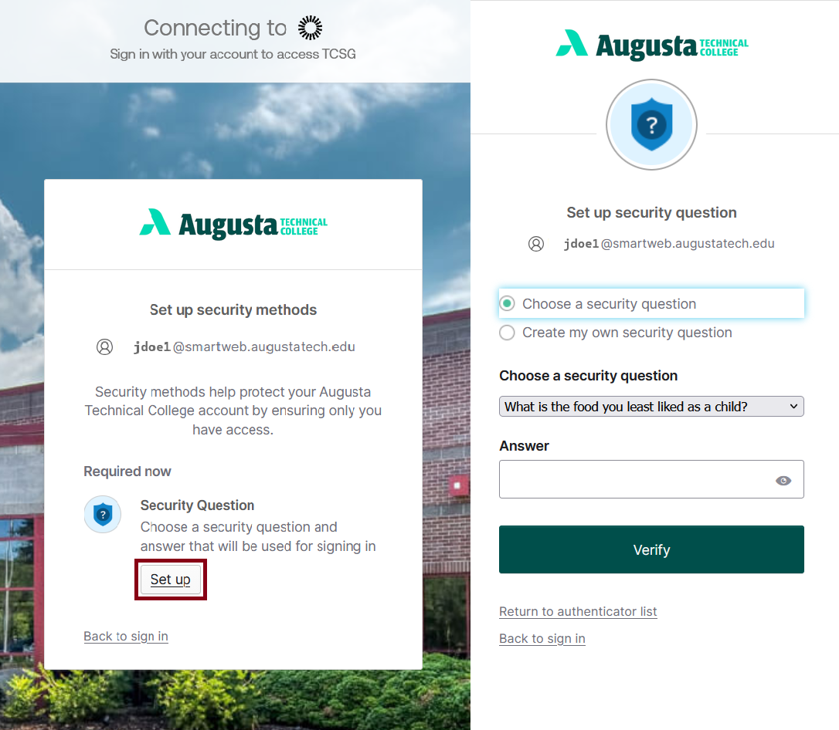
- Now you will be prompted to set up your multifactor authentication (MFA) methods. You have three Options:  • Google Authenticator  • Okta Verify  • Security Key or Biometric Authenticator  We Recommend you set up Okta Verify, and one other option in case you loose access to your primary method. | 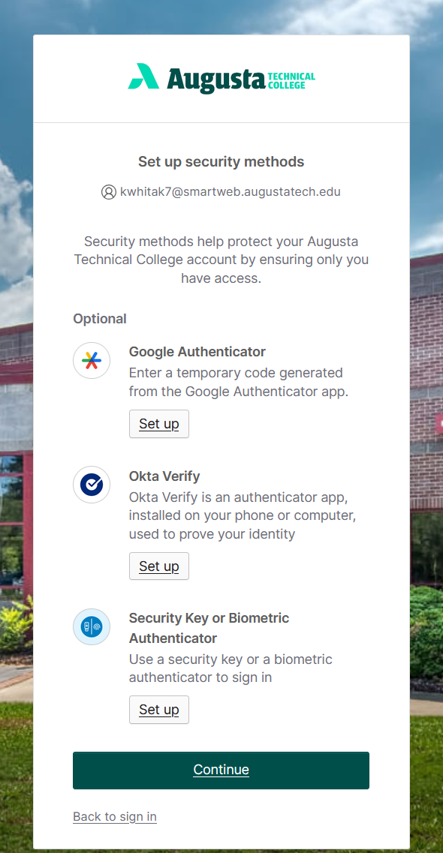
- GOOGLE AUTHENTICATOR  - Select either iPhone or Android  depending on your phone type.  This will take you to a screen with  instructions to download the app  and a QR Code.  - After downloading the app, select the plus sign in the bottom right corner in Authenticator to add an account.  - select “Scan QR Code”  - Scan the QR Code provided by OKTA, then click Next. | 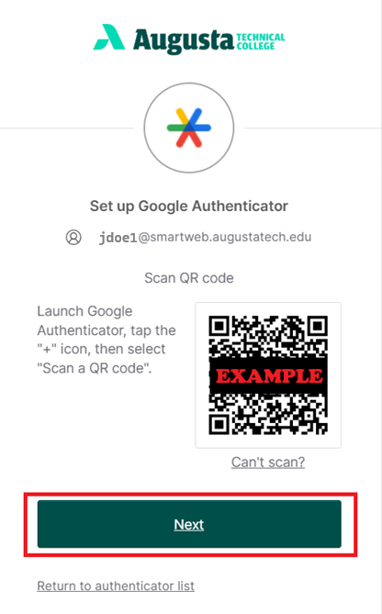
- Enter the 6 digit code from your authenticator app into the “Enter code” box and hit verify to finish the process.  Now you can set up an additional MFA method, or click continue.  - Okta Web Setup Guide  - Okta Mobile Setup Guide  - Security Key/Biometric Setup Guide | 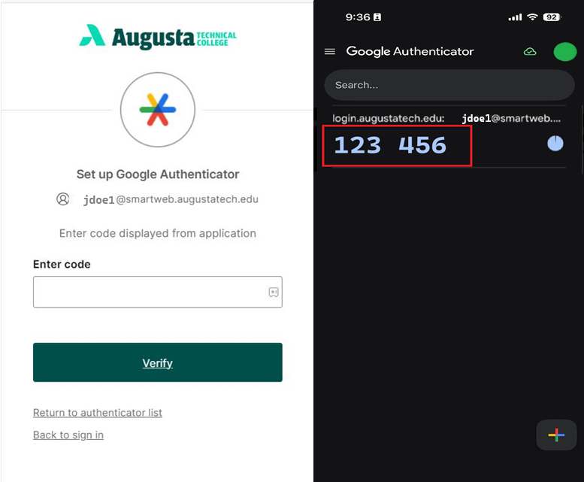
- Upon completion of your final MFA method, you will placed within the CougarWeb welcome page. | 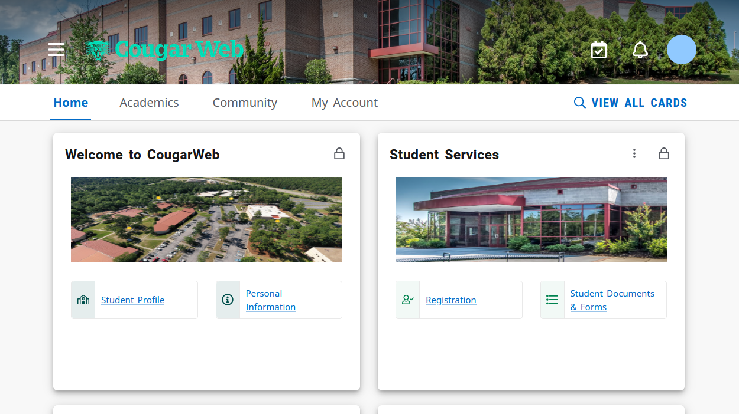
Want to remove or set up additional MFA Methods?  - Go to: login.augustatech.edu  - Login with your ATC email and password.  - In the upper right hand corner click your name, then settings | 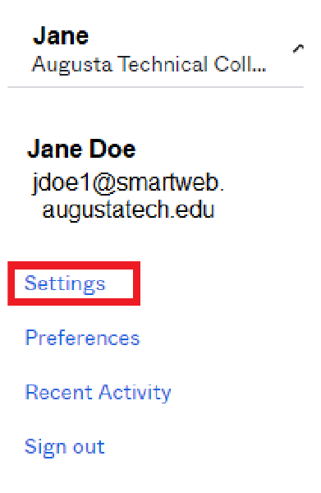
Clicking Settings will take you to the  - Okta Account page.  - Select Setup Another by the relevant method to add an additional option for that type.  - Select Remove by the relevant method to change the current options.  - Select Set up by the relevant method to add a method that has not been setup. | 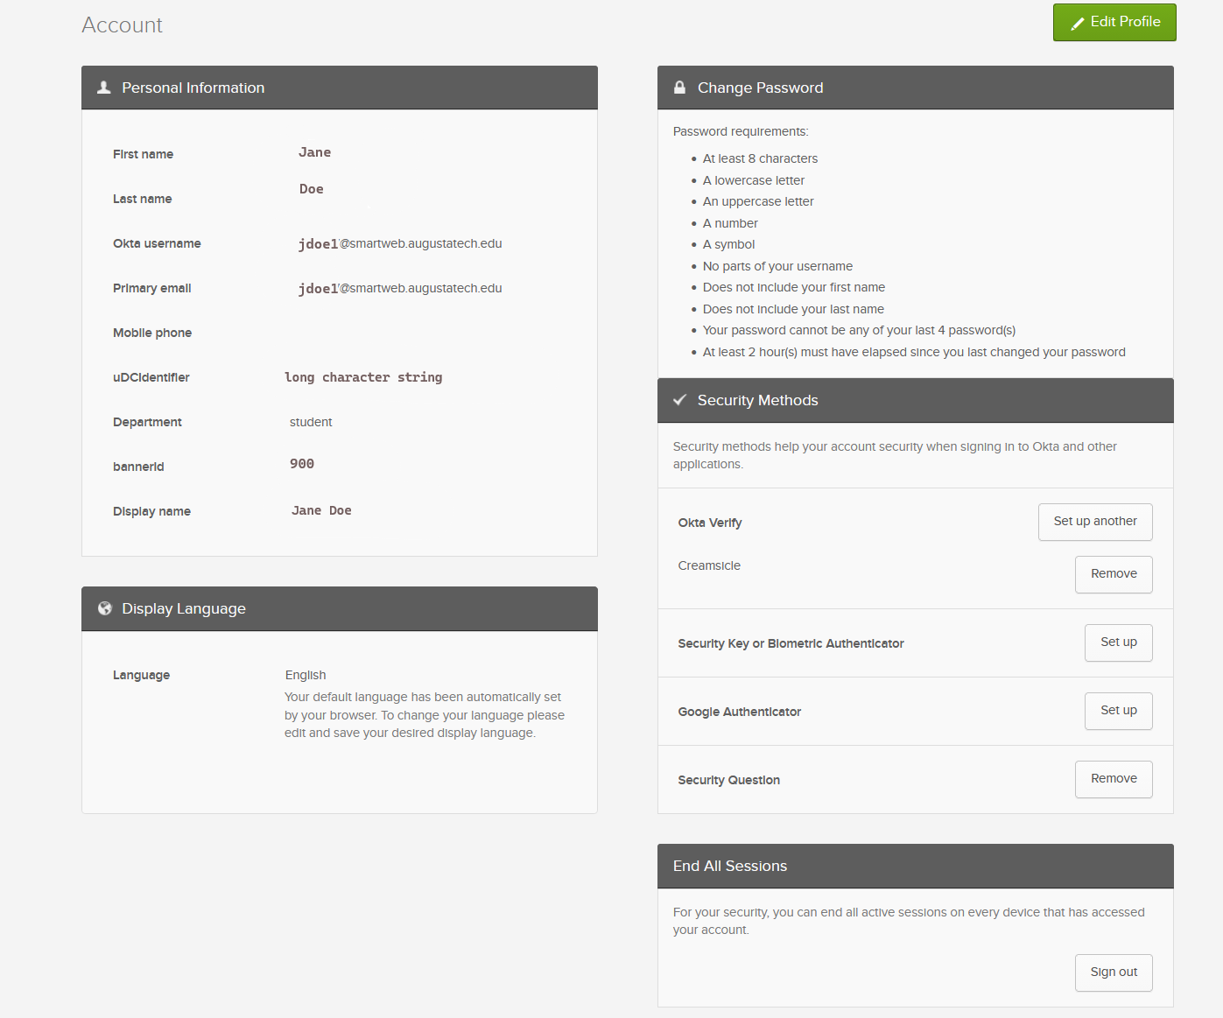
Need to reset your password? Go to the Okta Forgot Password? Reset Guide

