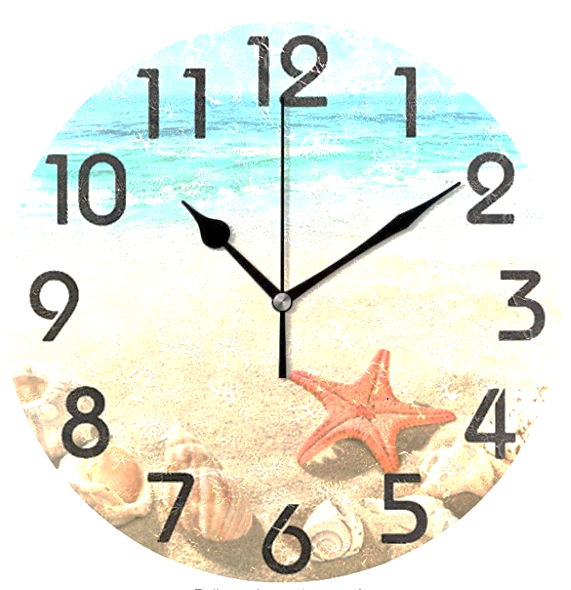
Summer Semester 2022
Academic Planner

MY CLASS, WORK & ACTIVITY SCHEDULE

 | MONDAY | TUESDAY | WEDNESDAY | THURSDAY | FRIDAY | SATURDAY | SUNDAY
3:00 a.m.
3:30 a.m.
4:00 a.m.
4:30 a.m.
5:00 a.m.
5:30 a.m.
6:00 a.m.
6:30 a.m.
7:00 a.m.
7:30 a.m.
8:00 a.m.
8:30 a.m.
9:00 a.m.
9:30 a.m.
10:00 a.m.
10:30 a.m.
11:00 a.m.
11:30 a.m.
12:00 p.m.
12:30 p.m.
1:00 p.m.
1:30 p.m.
2:00 p.m.
2:30 p.m.
3:00 p.m.
3:30 p.m.
4:00 p.m.
4:30 p.m.
5:00 p.m.
5:30 p.m.
6:00 p.m.
6:30 p.m.
7:00 p.m.
7:30 p.m.
8:00 p.m.
8:30 p.m.
9:00 p.m.
9:30 p.m.
10:00 p.m.
10:30 p.m.
11:00 p.m.
11:30 p.m.
12:00 a.m.
12:30 a.m.
1:00 a.m.
1:30 a.m.
2:00 a.m.
2:30 a.m.

Each Week fill in any requirements such as WORK, CLASSES, SPORT/MUSIC PRACTICE, COMMUNITY MEETINGS, FAMILY COMMITMENTS, CURRENT SCHEDULED APPOINTMENTS.

CLASS – When you are in the physical classroom. This is when you should be taking good notes, interacting with the classroom discussion and reviewing upcoming requirements for the class – tests, papers, projects, etc.

STUDY – During these times you should be pre-reading your textbook (read the chapter before the instructor reviews that chapter in class), study notes in preparation of future tests – more you look at the notes, the more you will retain on the day of the test. If it helps, rewrite your notes on the computer or create notecards for vocabulary and items that need to be memorized (helpful to see small amounts at one time). You will also complete class projects and do research during the study periods. (You need to be studying approximately 2 hours for every hour in class.)
May 2022
Sunday | Monday | Tuesday | Wednesday | Thursday | Friday | Saturday
1 | 2 | 3 | 4 | 5 | 6 | 7
8 | 9 | 10 | 11 | 12 | 13 | 14
15 | 16 | 17 | 18 | 19 | 20 | 21
22 | 23 | 24 | 25 | 26 | 27 | 28
29 | 30 | 31

June 2022
Sunday | Monday | Tuesday | Wednesday | Thursday | Friday | Saturday
 |  |  | 1 | 2 | 3 | 4
5 | 6 | 7 | 8 | 9 | 10 | 11
12 | 13 | 14 | 15 | 16 | 17 | 18
19 | 20 | 21 | 22 | 23 | 24 | 25
26 | 27 | 28 | 29 | 30

July 2022
Sunday |  | Monday | Tuesday | Wednesday | Thursday | Friday | Saturday
 |  |  |  |  |  | 1 | 2
3 |  | 4 | 5 | 6 | 7 | 8 | 9
10 |  | 11 | 12 | 13 | 14 | 15 | 16
17 |  | 18 | 19 | 20 | 21 | 22 | 23
24 | 31 | 25 | 26 | 27 | 28 | 29 | 30

August 2022
Sunday | Monday | Tuesday | Wednesday | Thursday | Friday | Saturday
 | 1 | 2 | 3 | 4 | 5 | 6
7 | 8 | 9 | 10 | 11 | 12 | 13
14 | 15 | 16 | 17 | 18 | 19 | 20
21 | 22 | 23 | 24 | 25 | 26 | 27
28 | 29 | 30 | 31

September 2022
Sunday | Monday | Tuesday | Wednesday | Thursday | Friday | Saturday
 |  |  |  | 1 | 2 | 3
4 | 5 | 6 | 7 | 8 | 9 | 10
11 | 12 | 13 | 14 | 15 | 16 | 17
18 | 19 | 20 | 21 | 22 | 23 | 24
25 | 26 | 27 | 28 | 29 | 30

October 2022
Sunday | Monday | Tuesday | Wednesday | Thursday | Friday | Saturday
 |  |  |  |  |  | 1
2 | 3 | 4 | 5 | 6 | 7 | 8
9 | 10 | 11 | 12 | 13 | 14 | 15
16 | 17 | 18 | 19 | 20 | 21 | 22
23 | 24 | 25 | 26 | 27 | 28 | 29
30 | 31
“If you want to conquer the anxiety of life, live in the moment, live in the breath.”
Amit Ray
Monday May 9, 2022
Student Break

Tuesday May 10, 2022
Student Break

Wednesday May 11, 2022
Bookstore/Financial Aid Purchases
Student Break

Thursday May 12, 2022
Bookstore/Financial Aid Purchases
Student Break

Friday May 13, 2022
Payment Deadline for Summer Semester 2022
Bookstore/Financial Aid Purchases
Student Break

Saturday May 14, 2022  Graduation at 1pm  James Brown Arena | Sunday May 15, 2022
Monday May 16, 2022
Summer Semester Begins
Late Registration - Add/Drop

Tuesday May 17, 2022
Late Registration - Add/Drop

Wednesday May 18, 2022
Late Registration - Add/Drop

Thursday May 19, 2022

Friday May 20, 2022

Saturday May 21, 2022  “A little nonsense now and then, is cherished by the wisest men.”  Anonymous  Armed Forces Day | Sunday May 22, 2022
Monday May 23, 2022

Tuesday May 24, 2022

Wednesday May 25, 2022

Thursday May 26, 2022

Friday May 27, 2022

Saturday May 28, 2022  “Happiness is part of who we are. Joy is the feeling.”  Tony DeLiso | Sunday May 29, 2022
Monday May 30, 2022
Memorial Day Observed – College Closed

Tuesday May 31, 2022

Wednesday June 1, 2022

Thursday June 2, 2022

Friday June 3, 2022

Saturday June 4, 2022  “It's a good idea always to do something relaxing prior to making an important decision in your life.”  Paulo Coelho | Sunday June 5, 2022
Monday June 6, 2022

Tuesday June 7, 2022

Wednesday June 8, 2022

Thursday June 9, 2022

Friday June 10, 2022

Saturday June 11, 2022  “Just breathing can be such a luxury sometimes.”  Walter Kim | Sunday June 12, 2022
Monday June 13, 2022

Tuesday June 14, 2022
Flag Day

Wednesday June 15, 2022

Thursday June 16, 2022

Friday June 17, 2022

Saturday June 18, 2022  “Work. Don’t Think. Relax.”  Ray Bradbury | Sunday June 19, 2022  Father’s Day  Juneteenth
Monday June 20, 2022
Juneteenth Observed – College Closed

Tuesday June 21, 2022

Wednesday June 22, 2022

Thursday June 23, 2022

Friday June 24, 2022

Saturday June 25, 2022  “The hardest thing is to do nothing and do it well.”  Marty Rubin | Sunday June 26, 2022
Monday June 27, 2022

Tuesday June 28, 2022

Wednesday June 29, 2022

Thursday June 30, 2022

Friday July 1, 2022

Saturday July 2, 2022  “Whenever you feel down, take a long walk-in nature.”  Michael Bassey Johnson | Sunday July 3, 2022
Monday July 4, 2022
Independence Day – College Closed

Tuesday July 5, 2022
Summer Semester Break
Student Holiday– College Open

Wednesday July 6, 2022
Summer Semester Break
Student Holiday– College Open

Thursday July 7, 2022
Summer Semester Break
Student Holiday– College Open

Friday July 8, 2022
Summer Semester Break
Student Holiday– College Open

Saturday July 9, 2022  “Hard work gives time to play harder, and smile at ease.”  Anthony Liccione | Sunday July 10, 2022
Monday July 11, 2022

Tuesday July 12, 2022

Wednesday July 13, 2022

Thursday July 14, 2022

Friday July 15, 2022

Saturday July 16, 2022  “Awareness of what is, without judgment, is relaxing, and is the best precondition for change.”  W. Timothy Gallwey | Sunday July 17, 2022
Monday July 18, 2022
Last Day to Withdraw with a grade of “W”

Tuesday July 19, 2022

Wednesday July 20, 2022

Thursday July 21, 2022

Friday July 22, 2022

Saturday July 23, 2022 | Sunday July 24, 2022
"As you work, rest."
Adeyemi Taiwo Eunice
Monday July 25, 2022

Tuesday July 26, 2022

Wednesday July 27, 2022

Thursday July 28, 2022

Friday July 29, 2022

Saturday July 30, 2022 | Sunday July 31, 2022
“Taking breaks isn’t about cheating yourself, it’s about treating yourself.”
Curtis Tyrone Jones
Monday August 1, 2022
Last Day of Classes

Tuesday August 2, 2022
Final Exams

Wednesday August 3, 2022
Final Exams

Thursday August 4, 2022
Final Exams

Friday August 5, 2022

Saturday August 6, 2022 | Sunday August 7, 2022
“The secret of relaxation is in these three words: ‘Let it go’!”
Dada J. P. Vaswani
Important Contact Information

Admissions Office
admission@augustatech.edu

Advising Center (Navigators)
advisingcenter@augustatech.edu
Career Services
careerservices@augustatech.edu

Counseling Center
counseling@augustatech.edu

Distance Education
distanceeducation@augustatech.edu

Dual Enrollment
dualenrollment@augustatech.edu

Financial Aid Office
finaid@augustatech.edu

IT Help Desk (Smartweb Resets)
augtech_it_helpdesk@augustatech.edu

Military Services
military@augustatech.edu

Student Accounts
stu.accounts@augustatetch.edu

Student Activities Office
studentactivities@augustatech.edu

Student Records Office
student.records@augustatech.edu

Testing Services
testingcenter@augustatech.edu

As set forth in its student catalog, Augusta Technical College does not discriminate on the basis of race, color, creed, national or ethnic origin, sex, religion, disability, age,
political affiliation or belief, genetic information, veteran status, or citizenship status
(except in those special circumstances permitted or mandated by law).

The following person(s) has been designated to handle inquiries regarding the
non-discrimination policies:

Shannon B. Patterson, Title IX Coordinator (Employees)
Augusta Campus/Building 100
Building 100 - Human Resources Suite
sbentley@augustatech.edu
706.771.4013

Migdaliz Berrios, Title IX/Equity Coordinator for Students (All Campuses)
Augusta Campus/Building 1300
migdaliz.berrios@augustatech.edu
706-771-5730

Julie Carter, Deputy Title IX Coordinator
Columbia County Center
jcarter@augustatech.edu
706.651-7368

Gregory Coursey, Deputy Title IX Coordinator
Waynesboro Campus
gcoursey@augustatech.edu
706-437-6808

Jeanette Lowe, Deputy Title IX Coordinator
Thomson Campus
jlowe@augustatech.edu
706-595-0166

Karissa D. Wright, ADA/504 Coordinator
Augusta Campus
Building 1300 – Counseling Center
kdavis@augustatech.edu
706.771.4067

The calendar in this planner is subject to change, for updates review the College’s Academic Calendar.

augustatech.edu

